**How to check Workflow**

Requirement: EFMS GUI

SPP Team engage EFMS Team to check stuck tasks for particular Order# in Workflow

Example: Order # 169668524

**EFMS GUI** [**URL :-**](URL:-)

[**http://efmsms.it.att.com:8008/MS**](http://efmsms.it.att.com:8008/MS)

1. How to open Order in EFMS GUI
2. Go to Order / Sub Order column on the left side of GUI

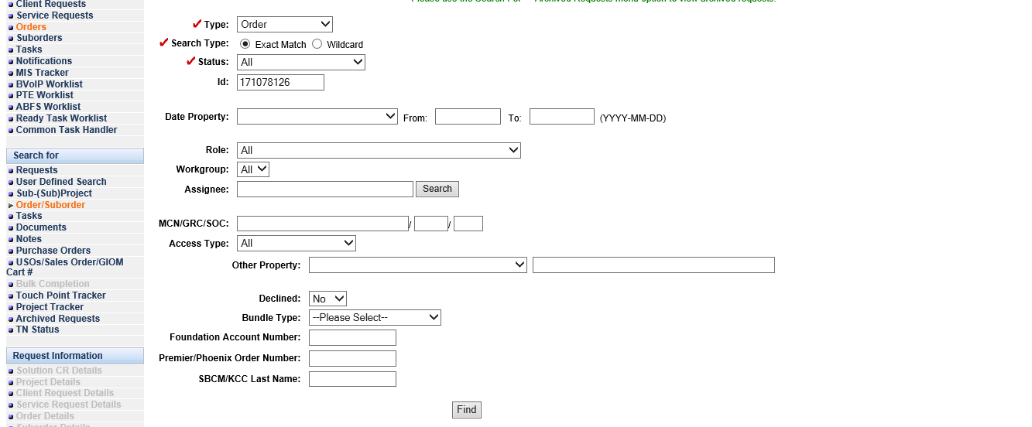

1. Fill the Required data in GUI –
2. Order Type and Order ID:

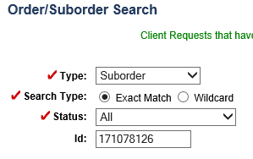

1. Click on Find Button to Open the Order in GUI

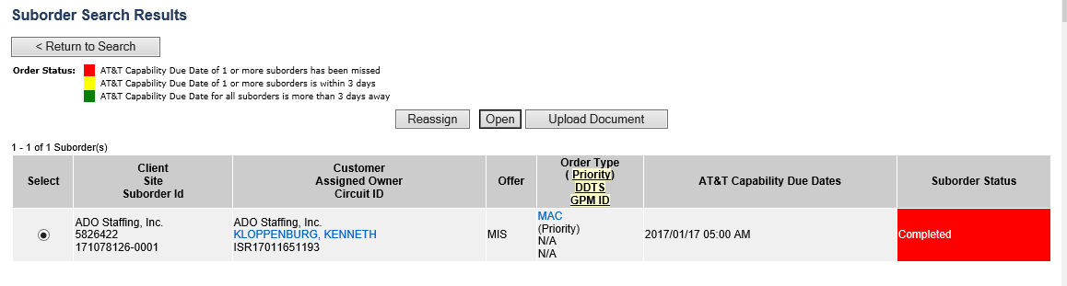

1. By Selecting Tab Select Tasks on Order Details page
2. We can get Tasks name which are stuck in Workflow for specific Order

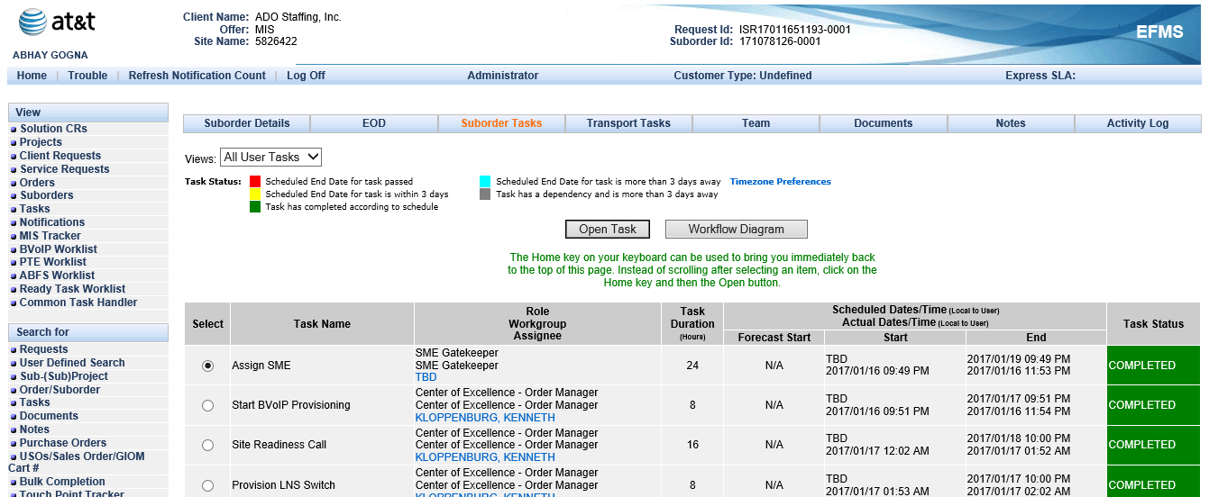

We can check the Ready and complete Tasks for Workflow - In EFMS GUI we need to select and open the particular task by clicking on Radio Button

To check the task in Ready State use the below query:

/\***Order Level check for MIS and BVOIP**\*/

Select ord.usrp_order_number,ms.ms_task_id,ord.transport_type,ms.answer,ord.ms_order_id,ord.tnt_completed_date, wf.name,ord.ms_order_id, wf.status, wf.job_id, wf.task_id, wf.first_ready_time,wf.ready_time,wf.done_time,wf.skipped_time, wf.perform_condition, wf.due_date,wf.skipped_time, wf.done_time from ms_order ord, ms_job j,wf_task wf,ms_task ms where Ord.Usrp_Order_Number In ( '171728408') and ord.ms_order_id= j.entity_id and j.entity_type=4 and wf.job_id = hextoraw(j.wf_job_id) And Wf.Task_Id= Ms.Wf_Task_Id and (Wf.Status In (1));

Screen shot from DB

----

/\***Suborder Level check for MIS and BVOIP**\*/

Select ord.purge_IND,ms.ms_task_id,ord.usrp_order_number,sub.order_gate1_status, sub.ms_sub_order_id,sub.wan_link_ip_addr, wf.name, wf.status, wf.job_id, wf.task_id, wf.first_ready_time,wf.ready_time, wf.due_date, wf.done_time, wf.first_ready_time,wf.skipped_time, wf.perform_condition, wf.ITERATE_CONDITION from ms_order ord, ms_sub_order sub,ms_job j,wf_task wf,wf_job job,ms_task ms where Ord.Usrp_Order_Number In ('172367242')And Ord.Ms_Order_Id = Sub.ms_order_id and ms_sub_order_id = j.entity_id and wf.job_id= hextoraw(j.wf_job_id) And Wf.Job_Id = Job.Job_Id and wf.task_id= ms.WF_TASK_ID And J.Entity_Type=5 and (Wf.Status In (1));

Screen shot from DB

**Note**: Task Status

-- 0 = Waiting

-- 1 = READY

-- 2 = ACQUIRED

-- 3 = Complete

-- 4 = Skipped

-- 5 = In-Progress